Worksheet 6: Capture Efficiency Method for Full Infiltration, Constant Drawdown BMPs

Part 1: Calculate the design depth and drawdown time
1 | Enter total effective storage depth (sum of values below) | D_{total_ effective} |  |  | inches
1a | Ponding storage depth | D_{pond} |  |  | inches
1b | Media effective storage depth (depth * 0.2) | D_{media_ effective} |  |  | inches
1c | Gravel effective storage (depth * 0.4) | D_{gravel_ effective} |  |  | inches
2a | Calculate design infiltration rate, K_{design} = K_{observed} / S_{total} (See Worksheet 3 and Appendix D) | K_{design}= |  |  | in/hr
2b | Calculate drawdown time (D_{total_effective} / K_{design}) | T_{drawdown}= |  |  | hours
2c | If using Method 2 for drawdown (Section E.2.5) which accounts for sidewall infiltration, insert result and attach relevant calculations below. | T_{drawdown}= |  |  | hours

Part 2: Determine the portion of the design storm for the BMP
3 | Using Figure E-4 or the figure within the worksheet below, determine the "fraction of design capture storm depth" at which the BMP drawdown time line intersects with 80% capture efficiency. Trace down to determine X₁ | X₁=
4 | Enter capture efficiency corresponding to upstream HSCs and/or upstream Harvest and Use BMPs, Y₂. | Y₂ = |  |  |  | %
5 | Using Figure E-4 or the figure within the worksheet below, determine the fraction of “design capture storm depth” at which the drawdown time of the BMP intersects with the equivalent of the upstream capture efficiency (Y₂). Trace down to determine X₂ | X₂=
6 | Calculate the fraction of design capture storm depth that must be provided by the BMP, fraction = X₁ – X₂ | fraction=
7 | Enter design capture storm depth from N-1, d (inches) | d= |  |  |  | inches
8 | Calculate the storm depth to use in sizing calculations, d_{fraction}= fraction × d | d_{fraction}= |  |  |  | inches

Part 3 Calculate the DCV (Section E.2.2)
9a | Enter DMA area tributary to BMP (s), A (acres) (not including any self-retaining areas) | A= |  |  |  | acres
9b | Enter DMA Imperviousness, imp | imp= |  |  |  | unitless
9c | Calculate runoff coefficient, C= (0.75 x imp) + 0.15 | C= |  |  |  | unitless
9d | Calculate the DCV= (C x d_{fraction} x A x 43560 x (1/12)) | DCV= |  |  |  | cu-ft

Part 3: Check footprint and drawdown times
10 | Footprint required to retain the DCV, DCV/D_{effective} (A_{BMP} is measured at the mid ponding depth for systems with side slopes) | A_{BMP} |  |  |  | sq ft
11a | Infiltrating surface area required to avoid premature clogging (from Section E.4.1), as percent of tributary impervious area | %A_{min,clog} |  |  |  | %
11b | Provided infiltrating surface area as a fraction of the tributary impervious surface (included wetted infiltrating area when BMP is half full) | %A_{infiltration_surface} |  |  |  | %

Supporting Calculations
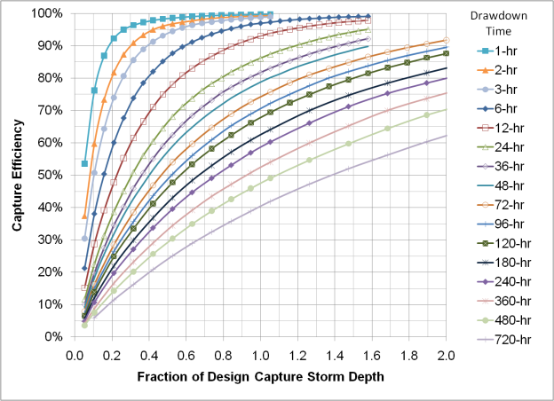

Provide supporting graphical operations.

