Worksheet 9: Flow-Based Compact Biofiltration with Supplemental Retention Method

Part 1: Determine the design storm intensity of the compact biofiltration BMP
1 | Enter the time of concentration, T_{c} (min) (See E.2.3) (account for upstream detention by increasing Tc to a maximum 60 minutes per Section E.3.5.2 if detention is provided) | T_{c}= |  | min
2 | Using Figure E-7 or the figure included in the worksheet, determine the design intensity at which the estimated time of concentration (T_{c}) achieves 80% capture efficiency, I₁ | I₁= |  | in/hr
3 | Enter capture efficiency corresponding to upstream HSCs and/or upstream BMPs, Y₂. Attach associated calculations. | Y₂ = |  | %
4 | Using Figure E-7, determine the design intensity at which the time of concentration (T_{c}) achieves the upstream capture efficiency(Y₂), I₂ | I₂= |  | in/hr
5 | Determine the design intensity that must be provided by BMP to achieve 80 percent capture, I_{design}= I₁-I₂ | I_{design_80%}= |  | in/hr

Part 2: Calculate the design flowrate of the compact biofiltration BMP (Section E.2.6)
6a | Enter DMA area tributary to BMP (s), A (acres) | A= |  | acres
6b | Enter DMA Imperviousness, imp (unitless) | imp=
6c | Calculate runoff coefficient, c= (0.75 x imp) + 0.15 | c=
6d | Calculate flowrate to achieve 80 percent capture, Q_{80%}= (c x I_{design} x A) | Q_{80%}= |  | cfs
7 | Calculate design flowrate, Q_{design}= Q_{80%} x 150% | Q_{design}= |  | cfs

Part 3: Demonstrate that Supplemental Retention BMPs Conform to Volume Reduction Targets (Only DMAs Categorized as “Biotreatment with Partial Infiltration”)
8 | Describe system, including features to maximize volume reduction (if applicable):
9 | Summarize calculations to demonstrate that volume reduction targets are met, where feasible and applicable.

Supporting Calculations
Provide time of concentration assumptions:

Graphical Operations
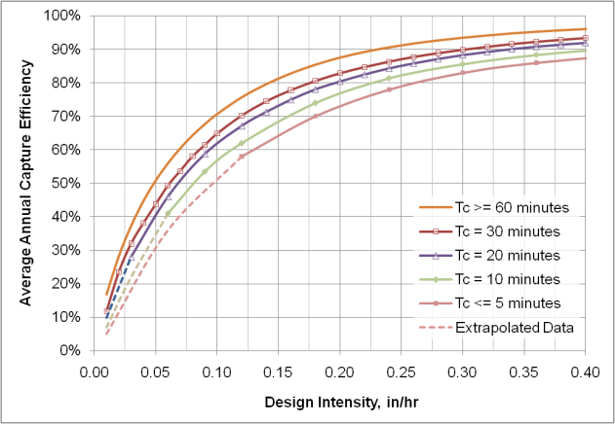

Provide supporting graphical operations in figure above.

