Worksheet 10: Nomograph Method for Determining Capture Efficiency of Harvest and Use BMPs

Part 1: Calculate the EIATA and the effect of upstream HSCs
1a | Landscape area irrigated with harvested water |  | LA= |  |  | acres
1b | Area-weighted landscape coefficient (typically 0.7 for active turf, 0.35 for conservation landscape design) |  | K_{L}=
1c | Irrigation efficiency (typically 0.90) |  | IE
1d | Enter DMA area tributary to BMP (s), A (acres) (not including any self-retaining areas) |  | A= |  |  | acres
1e | Enter DMA Imperviousness, imp (unitless) |  | imp=
1f | Effective Irrigated Area to Tributary Area ratio, EIATA = LA * K_{L} / (IE * imp * A) |  | EIATA |  |  | ac/ac
2 | Enter capture efficiency corresponding to upstream HSCs (Worksheet 4) and locate on Figure E-8 or the figure within the worksheet below |  | Y₁= |  |  | %
3 | Using Figure E-8 or the figure within the worksheet below, determine the cistern volume as a fraction of the DCV corresponding to the capture efficiency of the HSCs |  | X₁=

Part 2: Calculate the DCV
4 | 85th percentile, 24-hour design storm |  | d = |  |  | inches
5a | Calculate runoff coefficient, C= (0.75 x imp) + 0.15 |  | C=
5b | Calculate the DCV= (C x d x A x 43560 sf/ac x (1 ft/12 in)) |  | DCV= |  |  | cu-ft

Part 3: Calculate capture efficiency
6 | Storage Volume of BMP (cistern, vault, etc.) | V |  |  |  | cu ft
7 | Storage Volume as a fraction of DCV, V_{frac} = V/CDV | V_{frac}
8 | Final equivalent volume as a fraction of DCV from combination of HSCs and harvest and use BMPs,  X₂ = X₁ + V_{frac} | X₂
9 | Using Figure E-8 or the figure within the worksheet below, determine the capture efficiency of the harvest and use BMPs and any upstream HSCs | Y₂ |  |  |  | %

Supporting Calculations
Describe system:

Graphical Operations
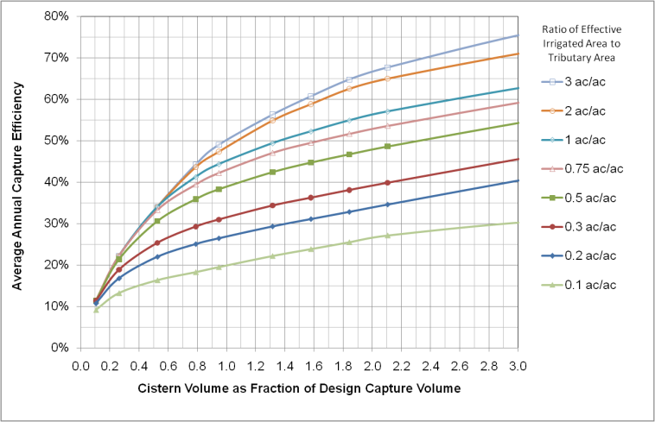

Provide supporting graphical operations.

