Worksheet 11: Capture Efficiency and Multiplier Method for Flow-Based Biotreatment BMPs

Part 1: Determine the design storm intensity and flow rate
1 | Enter the time of concentration, Tc (min) (See Section E.2.3) | T_{c}= |  | min
2 | If T_{c} is less than 20 minutes, then use I₁ = 0.2 in/hr. Otherwise, using Figure E-7or the figure included in the worksheet, determine the design intensity at which the estimated time of concentration (T_{c}) achieves 80% capture efficiency, I₁ | I₁= |  | in/hr
3a | Enter DMA area tributary to BMP (s), A (acres) | A= |  | acres
3b | Enter DMA Imperviousness, imp (unitless) | imp=
3c | Calculate runoff coefficient, c= (0.75 x imp) + 0.15 | c=
3d | Calculate design flowrate, Q= (c x I_{design} x A) | Q= |  | cfs

Supporting Calculations
Describe system:
Provide time of concentration assumptions:

Graphical Operations
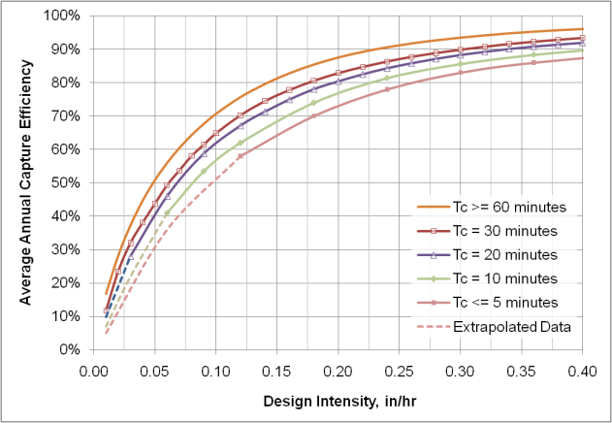

Provide supporting graphical operations.

